Michael Ghisilieri

CPE301 – SPRING 2016

Design Assignment 2

**DO NOT REMOVE THIS PAGE DURING SUBMISSION:**

The student understands that all required components should be submitted in complete for grading of this assignment.

|  |  |  |  |
| --- | --- | --- | --- |
| **NO** | **SUBMISSION ITEM** | **COMPLETED (Y/N)** | **MARKS**  **(/MAX)** |
| 0. | COMPONENTS LIST AND CONNECTION BLOCK DIAGRAM w/ PINS |  |  |
| 1. | INITIAL CODE OF TASK 1/A |  |  |
| 2. | INCREMENTAL / DIFFERENTIAL CODE OF TASK 1/B |  |  |
| 3. | INCREMENTAL / DIFFERENTIAL CODE OF TASK 1/C |  |  |
| 4. | INITIAL CODE OF TASK 2/A |  |  |
| 5. | INCREMENTAL / DIFFERENTIAL CODE OF TASK 2/B |  |  |
| 6. | INCREMENTAL / DIFFERENTIAL CODE OF TASK 2/C |  |  |
| 7. | SCHEMATICS |  |  |
| 8. | SCREENSHOTS OF EACH TASK OUTPUT |  |  |
| 9. | SCREENSHOT OF EACH DEMO |  |  |
| 10. | VIDEO LINKS OF EACH DEMO |  |  |
| 11. | GITHUB LINK OF THE DA |  |  |
|  |  |  |  |
|  |  |  |  |

|  |  |  |  |
| --- | --- | --- | --- |
| 0. | COMPONENTS LIST |  |  |

ATmega328P Chip x1

500 Ω resistor x11

Kingbright DC10EWA LED Bargraph x1

Red LED x1

|  |  |  |  |
| --- | --- | --- | --- |
| 1. | INITIAL CODE OF TASK 1/A |  |  |

;

; DA2_Task1.asm

;

; Created: 3/1/2016 7:01:20 PM

; Author : Michael

;

; Macro that initializes stack pointer

.MACRO INITSTACK

LDI R16, HIGH(RAMEND)

OUT SPH, R16

LDI R16, LOW(RAMEND)

OUT SPL, R16

.ENDMACRO

SBI DDRC, 0 ; set PC0 as an output

LDI R16, 0x00 ; load zero into R16

OUT DDRC, R16 ; clear PC0

Counter:

CALL Delay ; call delay for 0.25 seconds

LDI R22, 0x01 ; load one into R22

OUT PORTC, R22 ; set PC0 high

CALL Delay ; call delay for 0.25 seconds

LDI R22, 0x00 ; load zero into R22

OUT PORTC, R22 ; set PC0 low

JMP Counter ; loop back

; based on simulation

; total delay will be 1_999_945 cycles at 8 MHz so 1_999_945/8_000_000 = .24999 seconds

; value calculated by hand was a slightly larger than 2_000_000 but still very close to

; the total delay and the total delay is actually closer than the calculated value

Delay:

PUSH R16

PUSH R17

PUSH R18 ; push registers used in function call

LDI R16, 25 ; outer loop value loaded 1 time

L1: ; 3*25 = 75 without extra branch cycles

LDI R17, 94 ; middle loop value loaded 25 times

L2: ; 3*94*25 = 7_050 without extra branch cycles

LDI R18, 212 ; inner loop value loaded 2350 times

L3: ; 4*94*212*25 = 1_992_800 without extra branch cycles

NOP

DEC R18

BRNE L3

DEC R17

BRNE L2

DEC R16

BRNE L1

POP R18

POP R17

POP R16 ; pop registers used in function call

RET ; return back to counter loop

|  |  |  |  |
| --- | --- | --- | --- |
| 2. | INCREMENTAL / DIFFERENTIAL CODE OF TASK 1/B |  |  |

;

; DA2_Task2.asm

;

; Created: 3/1/2016 1:50:09 PM

; Author : Michael

;

; Macro that initializes stack pointer

.MACRO INITSTACK

LDI R16, HIGH(RAMEND)

OUT SPH, R16

LDI R16, LOW(RAMEND)

OUT SPL, R16

.ENDMACRO

SBI DDRB, 0

SBI DDRB, 1

SBI DDRB, 2

SBI DDRB, 3

SBI DDRB, 4

SBI DDRB, 5

SBI DDRB, 6

SBI DDRB, 7 ; set every pin of PORTB as an output for bargraph

SBI DDRC, 0

SBI DDRC, 5

SBI DDRC, 4 ; set pins 5 and 4 as outputs for bargraph

LDI R16, 0x00

OUT PORTB, R16 ; turn off all LEDs on bargraph

OUT PORTC, R16 ; turn off all LEDs on bargraph

LDI R20, 0x00 ; initialize counter to zero

LDI R21, 0x00 ; second counter to check if value is 5 or 10

Counter:

CALL Delay ; delay for 0.25 seconds

INC R20 ; increment counter

OUT PORTB, R20 ; update value of counter on LED bargraph

INC R21 ; increment register checking for 5th/10th rising edge

; the two extra LEDs (9 and 10) will always be in 1 out of 4 different states

CPI R21, 5 ; if first 5th pulse

BREQ Fifth ; branch and set accordingly

CPI R21, 10 ; if first 10th pulse

BREQ Tenth ; branch and set accordingly

CPI R21, 15 ; if second 5th pulse

BREQ Fifteenth ; branch and set accordingly

CPI R21, 20 ; if second 10th pulse

BREQ Twentieth ; branch and set accordingly

JMP NegEdge ; if not 5th or 10th pulse don't update LEDs and jump to NegEdge label

; since PC6 was a reset pin I used PC4 instead

; so PC4 is used as the 10th LED and PC5 is still 9th

Fifth:

LDI R16, 0x20

OUT PORTC, R16 ; first 5th pulse where PC4 = 0 and PC5 = 1

JMP NegEdge ; jump to negative edge delay

Tenth:

LDI R16, 0x10

OUT PORTC, R16 ; first 10th pulse where PC4 = 1 and P4C5 = 0

JMP NegEdge ; jump to negative edge delay

Fifteenth:

LDI R16, 0x30 ;0x60

OUT PORTC, R16 ; second 5th pulse where PC4 = 1 and PC5 = 1

JMP NegEdge ; jump to negative edge delay

Twentieth:

LDI R16, 0x00 ;0x00

OUT PORTC, R16 ; second 10th pulse where PC4 = 0 and PC5 = 0

LDI R21, 0x00 ; set counter back to zero for checks

JMP NegEdge ; jump to negative edge delay

NegEdge:

CALL Delay ; delay for 0.25 seconds

JMP Counter

; based on simulation

; total delay will be 1_999_945 cycles at 8 MHz so 1_999_945/8_000_000 = .24999 seconds

; value calculated by hand was a slightly larger than 2_000_000 but still very close to

; the total delay and the total delay is actually closer than the calculated value

Delay:

PUSH R16

PUSH R17

PUSH R18 ; push registers used in function call

LDI R16, 25 ; outer loop value loaded 1 time

L1: ; 3*25 = 75 without extra branch cycles

LDI R17, 94 ; middle loop value loaded 25 times

L2: ; 3*94*25 = 7_050 without extra branch cycles

LDI R18, 212 ; inner loop value loaded 2350 times

L3: ; 4*94*212*25 = 1_992_800 without extra branch cycles

NOP

DEC R18

BRNE L3

DEC R17

BRNE L2

DEC R16

BRNE L1

POP R18

POP R17

POP R16 ; pop registers used in function call

RET ; return back to counter loop

|  |  |  |  |
| --- | --- | --- | --- |
| 3. | INCREMENTAL / DIFFERENTIAL CODE OF TASK 1/C |  |  |

;

; DA2_Task3.asm

;

; Created: 3/3/2016 4:20:18 PM

; Author : Michael

;

.ORG 0x00 ; set program counter to 0x00

RJMP INIT ; jump to INIT label skipping by interrupt at 0x16

.ORG 0x16 ; location of TIM1_COMPA in interrupt table

RJMP TIM1_COMPA ; jump to TIM1_COMPA every time interrupt occurs

INIT:

; Macro that initializes stack pointer

.MACRO INITSTACK

LDI R16, HIGH(RAMEND)

OUT SPH, R16

LDI R16, LOW(RAMEND)

OUT SPL, R16

.ENDMACRO

INITSTACK

SBI DDRB, 0

SBI DDRB, 1

SBI DDRB, 2

SBI DDRB, 3

SBI DDRB, 4

SBI DDRB, 5

SBI DDRB, 6

SBI DDRB, 7 ; set every pin of PORTB as an output for bargraph

SBI DDRC, 0

SBI DDRC, 5

SBI DDRC, 4 ; set pins 5 and 6 as outputs for bargraph

LDI R16, 0x00

OUT PORTB, R16 ; turn off all LEDs on bargraph

OUT PORTC, R16 ; turn off all LEDs on bargraph

LDI R20, 0x00 ; initialize counter to zero

LDI R21, 0x00 ; second counter to check if value is 5 or 10

Begin:

LDI R24, 0x0F ; load 0x0F into R24

STS OCR1AH, R24 ; store 0x0F into the high register of OCR1A

LDI R24, 0x42 ; load 0x42 into R24

STS OCR1AL, R24 ; store 0x42 into the low register of OCR1A

LDI R24, 0x00 ; load 0x00 into R24

STS TCCR1A, R24 ; set CTC and have OC1A be disconnected to not change bits on bargraph

LDI R24, 0x0D ; load 0x0D into R24

STS TCCR1B, R24 ; set prescaler to 1024 and WGM12 bit high

LDI R24, 0x02 ; load 0x02 into R24

STS TIMSK1, R24 ; set OCIEA1 high to enable interrupts for OCF1A

SEI ; enable global interrupts

Forever:

RJMP Forever ; loop forever and wait for interrupt to occur every 0.5 second

TIM1_COMPA:

INC R20 ; increment counter

OUT PORTB, R20 ; update value of counter on LED bargraph

INC R21 ; increment register checking for 5th/10th rising edge

; the two extra LEDs will always be in 1 out of 4 different states

CPI R21, 5 ; if first 5th pulse

BREQ Fifth ; branch and set accordingly

CPI R21, 10 ; if first 10th pulse

BREQ Tenth ; branch and set accordingly

CPI R21, 15 ; if second 5th pulse

BREQ Fifteenth ; branch and set accordingly

CPI R21, 20 ; if second 10th pulse

BREQ Twentieth ; branch and set accordingly

JMP ToggleDone ; don't update LEDs and jump to negative edge delay

Fifth:

LDI R16, 0x20

OUT PORTC, R16 ; first 5th pulse where PC4 = 0 and PC5 = 1

JMP ToggleDone ; jump to negative edge delay

Tenth:

LDI R16, 0x10

OUT PORTC, R16 ; first 10th pulse where PC4 = 1 and PC5 = 0

JMP ToggleDone ; jump to negative edge delay

Fifteenth:

LDI R16, 0x30

OUT PORTC, R16 ; second 5th pulse where PC4 = 1 and PC5 = 1

JMP ToggleDone ; jump to negative edge delay

Twentieth:

LDI R16, 0x00

OUT PORTC, R16 ; second 10th pulse where PC4 = 0 and PC5 = 0

LDI R21, 0x00 ; set counter back to zero for checks

JMP ToggleDone ; jump to negative edge delay

ToggleDone:

LDI R24, 0x02 ; load 0x02 into R24

STS TIFR1, R24 ; clear OCF1A flag

RETI

|  |  |  |  |
| --- | --- | --- | --- |
| 4. | INITIAL CODE OF TASK 2/A |  |  |

/*

* DA2_Task4.c

*

* Created: 3/4/2016 9:54:58 AM

* Author : Michael

*/

#define F_CPU 8000000UL // define 8 MHz clock

#include <avr/io.h> // include IO library

#include <util/delay.h> // include library for _delay_ms function

void delay (); // function declaration for delay

int main(void)

{

DDRC |= (1 << PC0); // set PC0 as output

PORTC = 0; // clear value on PC0

while(1) { // loop forever

delay(); // call delay function for 250ms delay (.25 seconds)

PORTC |= 0x01; // set PC1 high

delay(); // call delay function for 250ms delay (.25 seconds)

PORTC = 0; // set PC0 low

}

}

void delay () { // function body

int i; // declare i for counter

for(i = 0; i < 25; i++) { // loop 25 times

_delay_ms(10); // delay 10 ms

} // total delay = 25*10ms = 250ms

}

|  |  |  |  |
| --- | --- | --- | --- |
| 5. | INCREMENTAL / DIFFERENTIAL CODE OF TASK 2/B |  |  |

/*

* DA2_Task5.c

*

* Created: 3/4/2016 10:48:55 AM

* Author : Michael

*/

#define *F_CPU* 8000000UL // define 8 MHz clock

#include <avr/io.h> // include IO library

#include <util/delay.h> // include library for _delay_ms function

void delay (); // function declaration for delay

int main(void)

{

int counter = 0; // set counter for LED bargraph starting at 0

int multiple = 0; // set counter for 5th/10th rising edge starting at 0

DDRB = 0xFF; // set every pin on PORTB as an output

DDRC = 0x30; // set PC4 an PC5 as outputs on PORTC

while(1) { // loop forever

delay(); // call delay function for 250ms delay (.25 seconds)

counter++; // increment counter after delay

if(counter > 255) // if counter went above 255 (9th bit)

counter = 0; // reset counter back to zero

PORTB = counter; // output counter to LED bargraph

multiple++; // increment counter for 5th/10th checks

switch(multiple) {

case 5: // if first 5th rising edge

PORTC = 0x20; // PC4 = 0 and PC5 = 1

break;

case 10: // if first 10th rising edge

PORTC = 0x10; // PC4 = 1 and PC5 = 0

break;

case 15: // if second 5th rising edge

PORTC = 0x30; // PC4 = 1 and PC5 = 1

break;

case 20: // if second 10th rising edge

PORTC = 0x00; // PC4 = 0 and PC5 = 0

multiple = 0; // clear check counter

break;

default:

break;

}

delay(); // call delay function for 250ms delay (.25 seconds)

}

}

void delay () { // function body

int i; // declare i for counter

for(i = 0; i < 25; i++) { // loop 25 times

*_delay_ms*(10); // delay 10 ms

} // total delay = 25*10ms = 250ms

}

|  |  |  |  |
| --- | --- | --- | --- |
| 6. | INCREMENTAL / DIFFERENTIAL CODE OF TASK 2/C |  |  |

/*

* DA2_Task6.c

*

* Created: 3/4/2016 11:10:02 AM

* Author : Michael

*/

#define *F_CPU* 8000000UL // define 8 MHz clock

#include <avr/io.h> // include IO library

#include <avr/interrupt.h> // include library for interrupts

int counter; // global variable for counter

int multiple; // global variable for check counter (5th/10th)

ISR(TIMER1_COMPA_vect) // interrupt subroutine body

{

counter++; // increment counter for LED bargraph

if(counter > 255) // if counter went above 255 (9th bit)

counter = 0; // reset counter back to zero

PORTB = counter; // output counter to LED bargraph

multiple++; // increment counter for 5th/10th checks

switch(multiple) {

case 5: // if first 5th rising edge

PORTC = 0x20; // PC4 = 0 and PC5 = 1

break;

case 10: // if first 10th rising edge

PORTC = 0x10; // PC4 = 1 and PC5 = 0

break;

case 15: // if second 5th rising edge

PORTC = 0x30; // PC4 = 1 and PC5 = 1

break;

case 20: // if second 10th rising edge

PORTC = 0x00; // PC4 = 0 and PC5 = 0

multiple = 0; // clear check counter

break;

default:

break;

}

}

int main(void)

{

counter = 0; // initialize counter to zero

multiple = 0; // initialize check counter to zero

DDRB = 0xFF; // set all of PORTB as outputs

DDRC = 0x30; // set PC4 and PC5 as outputs

TCCR1B |= 0x0D; // setup up CTC mode and prescaler (1024) for timer

TCNT1 = 0; // initialize timer1 to zero

OCR1A = 3906; // set CTC value

TIMSK1 |= (1 << OCIE1A); //enable compare interrupt

sei(); // enable global interrupts

while (1) // loop forever and execute interrupt

{ // subroutine every 0.5 seconds

}

}

|  |  |  |  |
| --- | --- | --- | --- |
| 7. | SCHEMATIC |  |  |

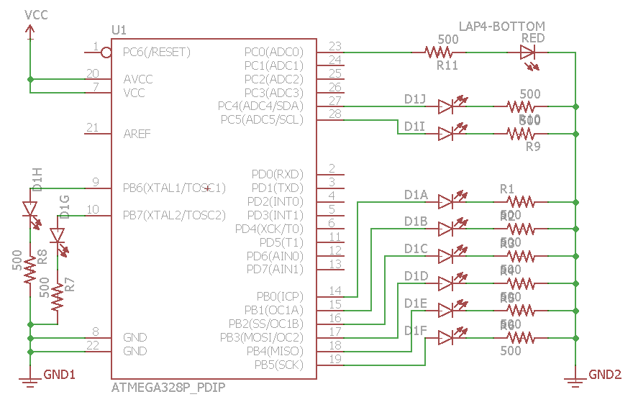

|  |  |  |  |
| --- | --- | --- | --- |
| 8. | SCREENSHOTS OF EACH TASK OUTPUT |  |  |

TASK 1/A/B with Assembly:

After first CALL of Delay, 250ms. Next call will also be 250ms creating a 0.5 second period with 50% DC.

**Simulation**

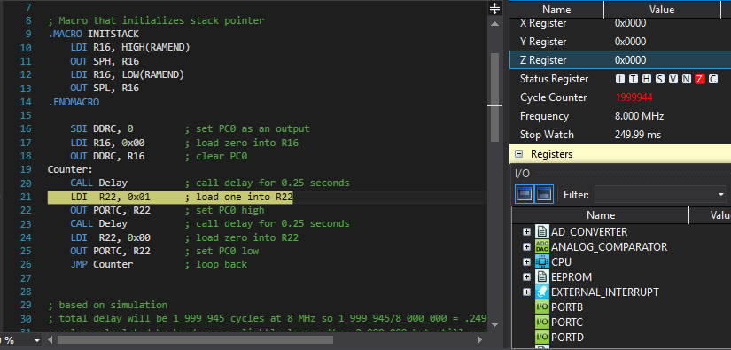

**Emulation**

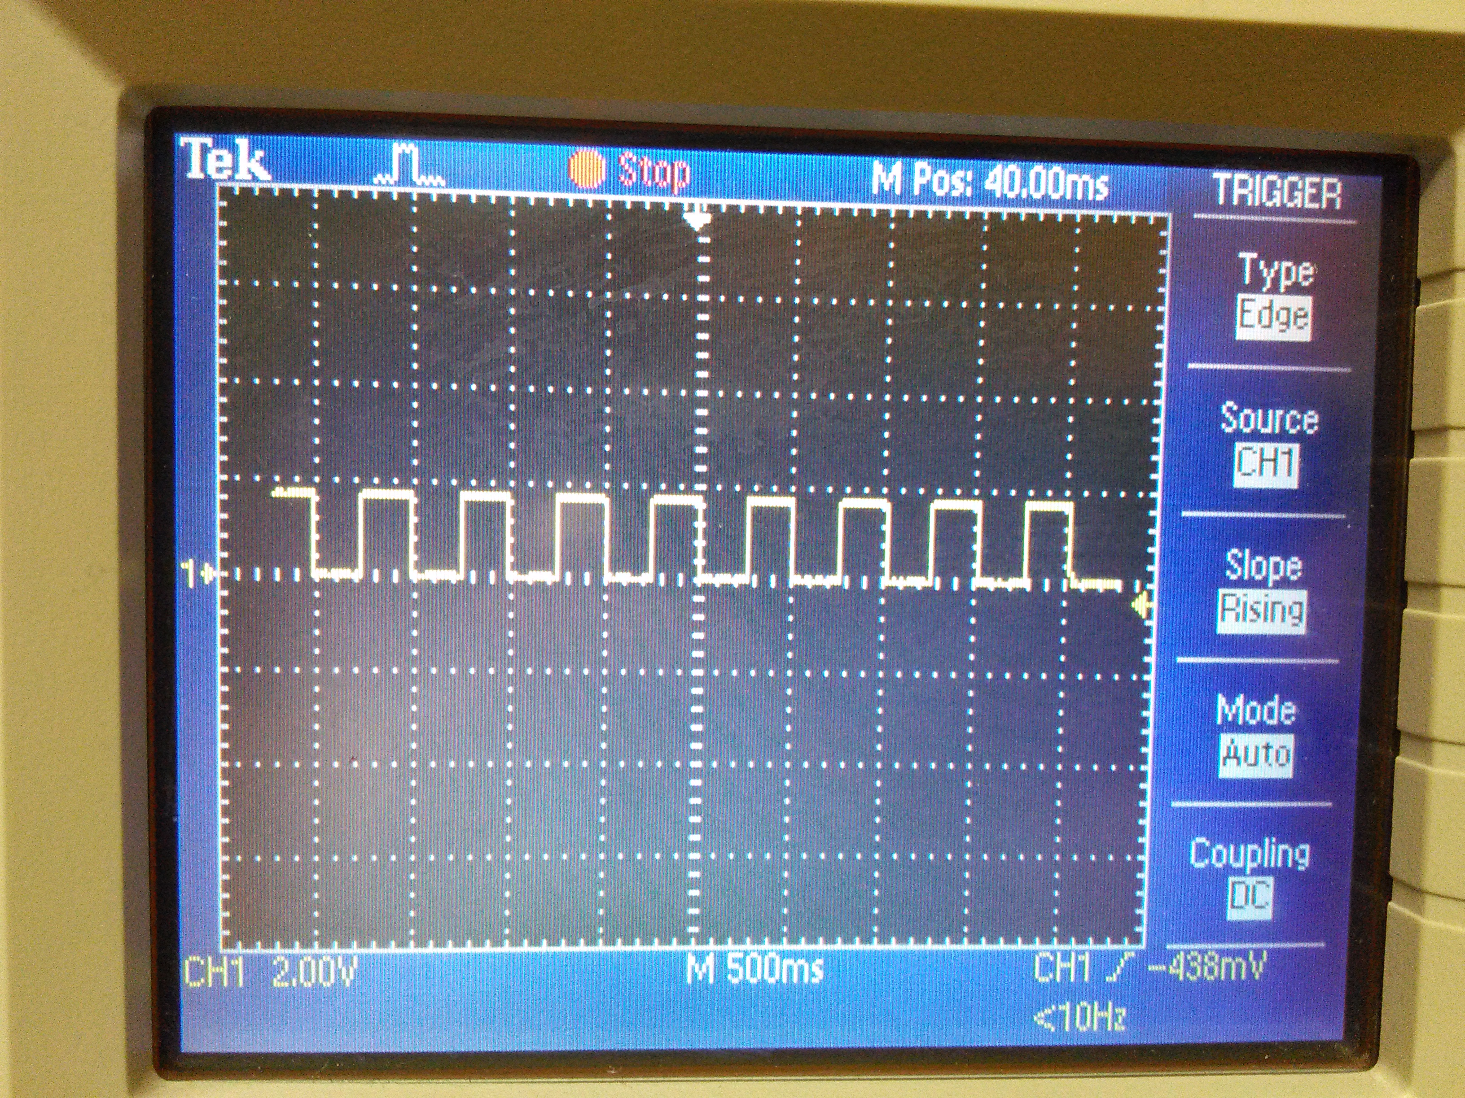

TASK 1/C with Assembly:

The interrupt for this task is triggered every 0.5 seconds to increment the counters every rising edge.

**Simulation**

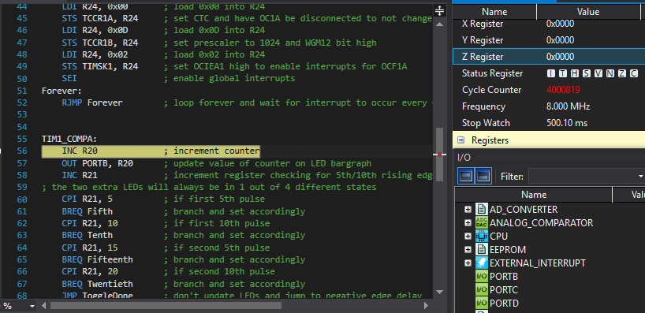

**Emulation**

Image is identical to the oscilloscope measurement for Assembly.

TASK 2/A/B with C:

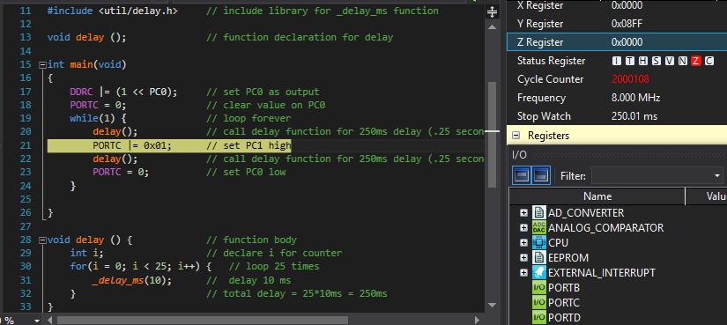

**Emulation**

Image is identical to the oscilloscope measurement for Assembly.

TASK 2/C with C:

The interrupt for this task is triggered every 0.5 seconds to increment the counters every rising edge.

**Simulation**

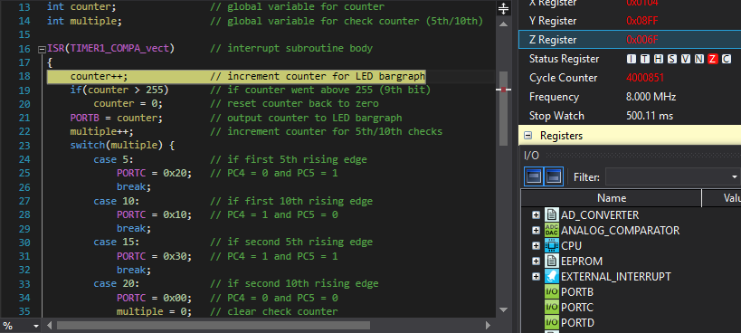

**Emulation**

Image is identical to the oscilloscope measurement for Assembly.

|  |  |  |  |
| --- | --- | --- | --- |
| 9. | SCREENSHOT OF EACH DEMO |  |  |

TASK 1/A and TASK 2/A used the same circuit

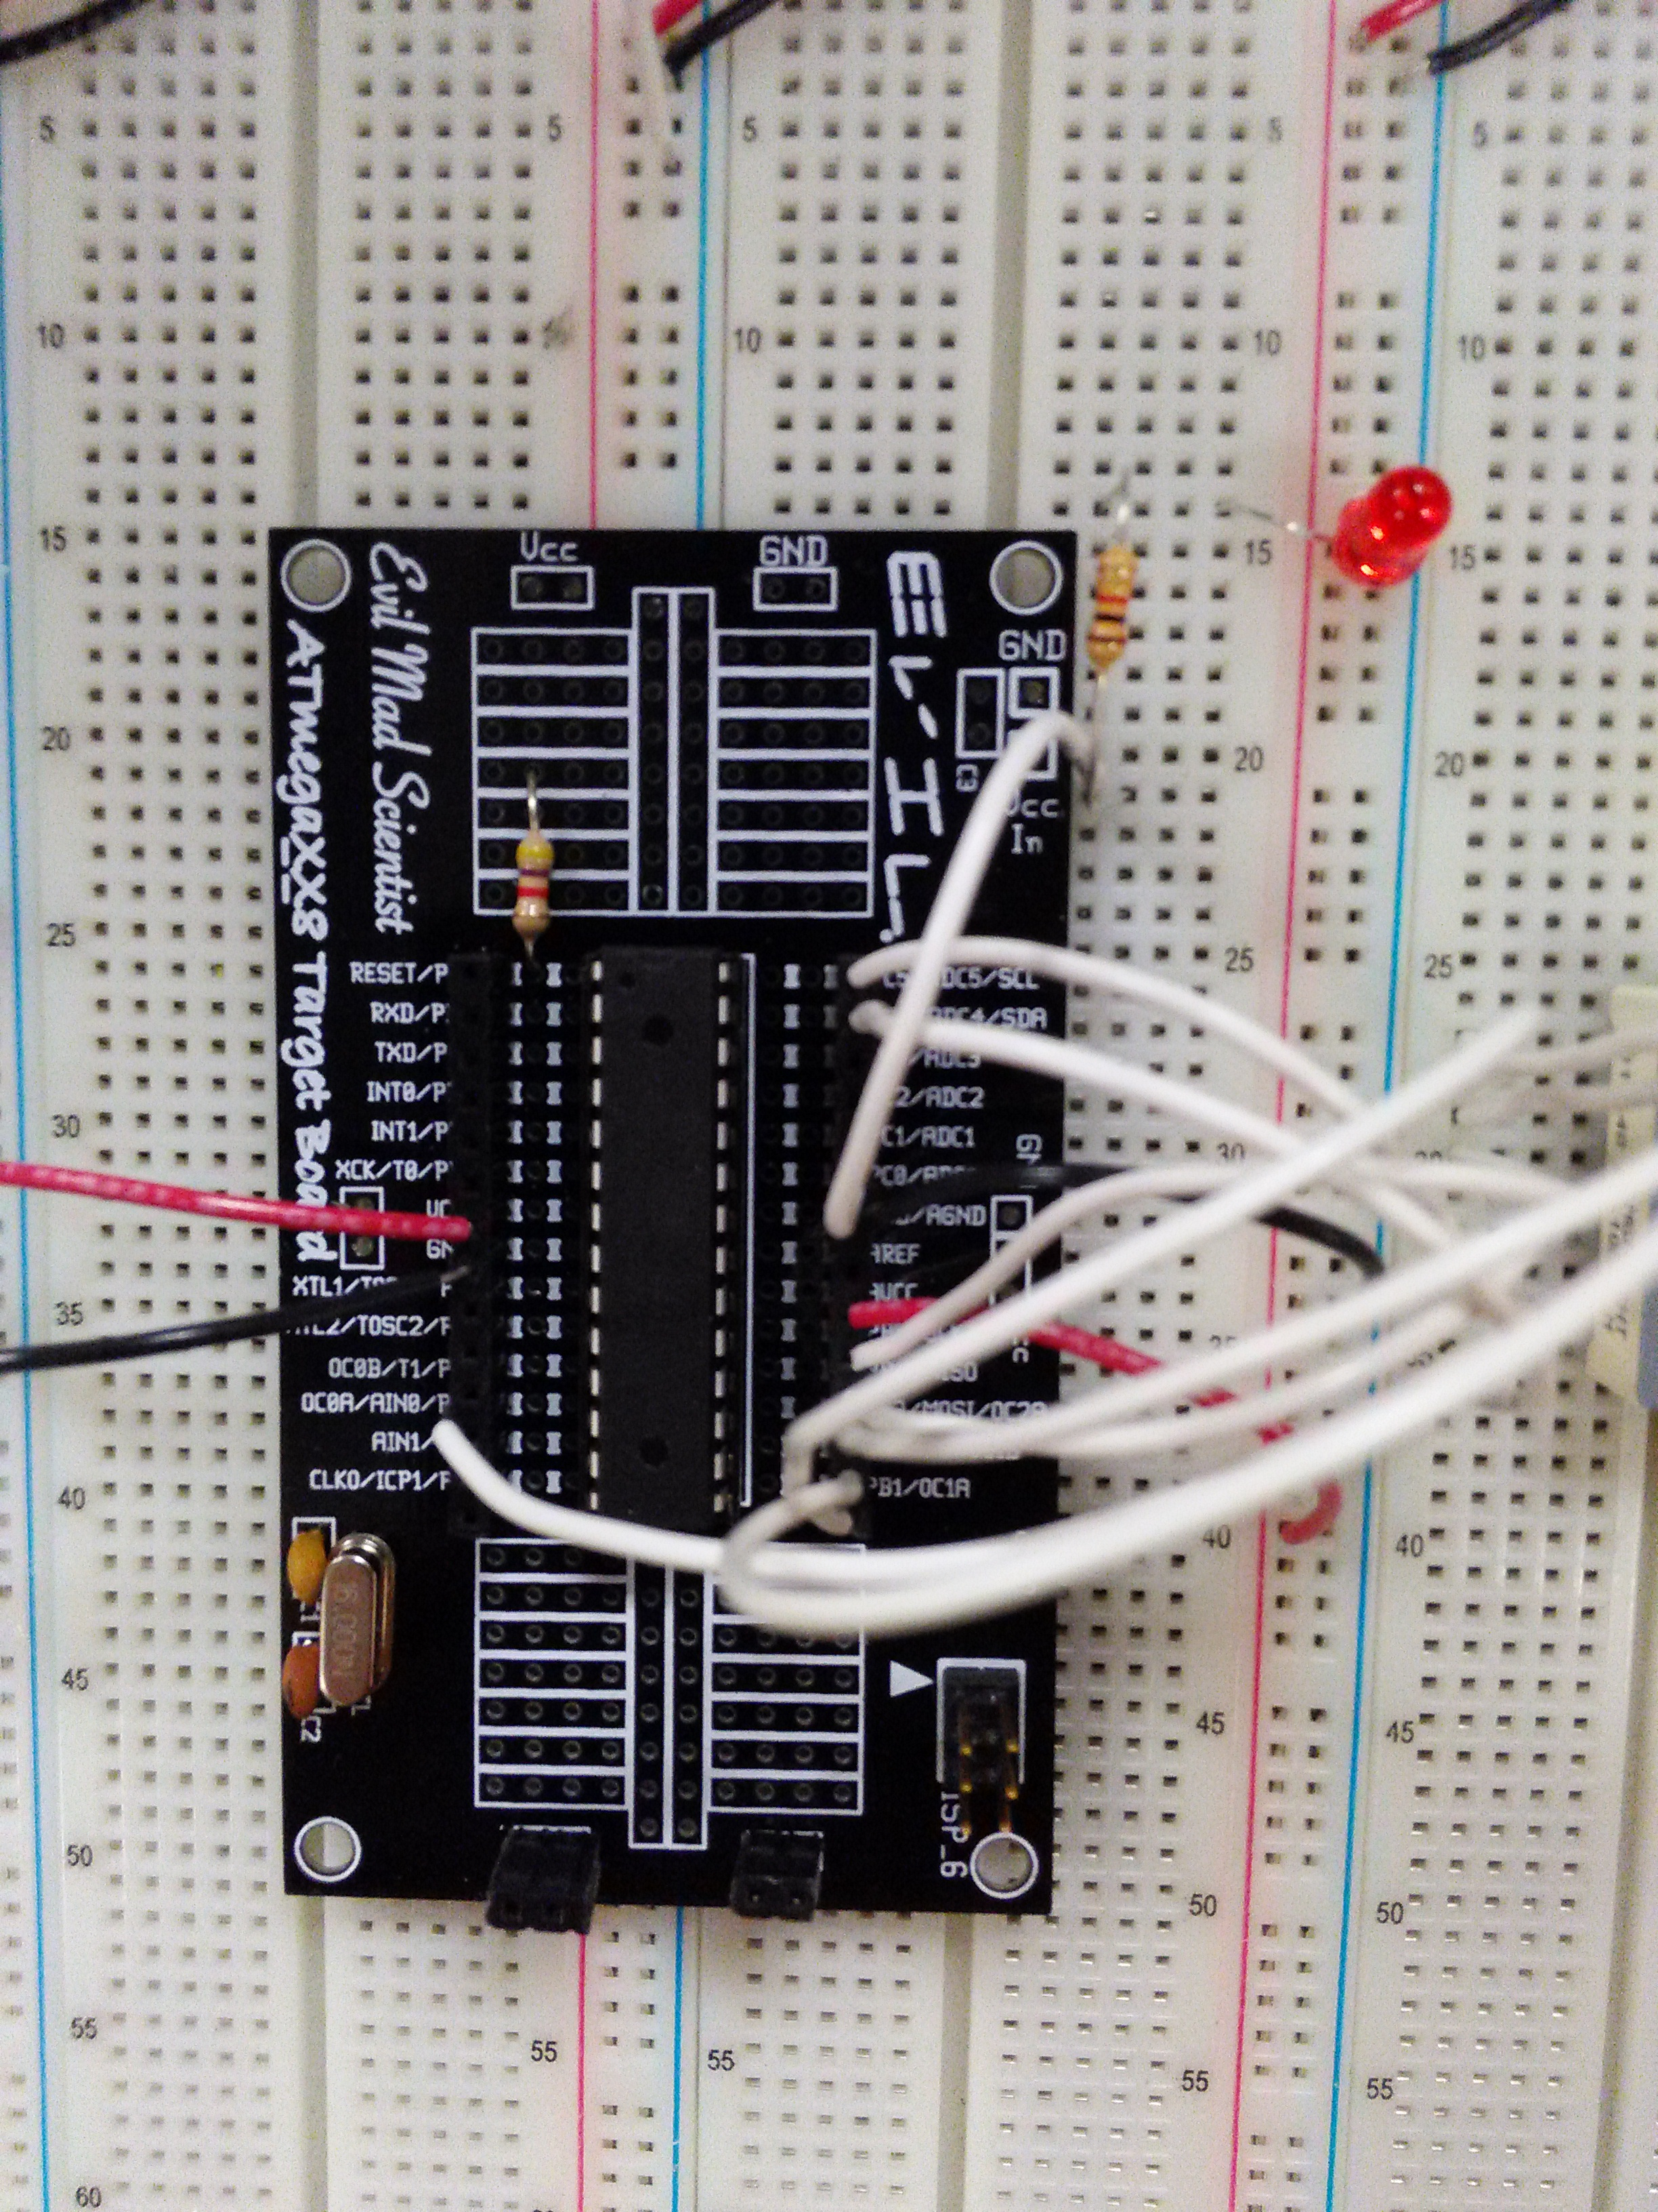

TASK 1/B/C and TASK 2/B/C all used the same circuit

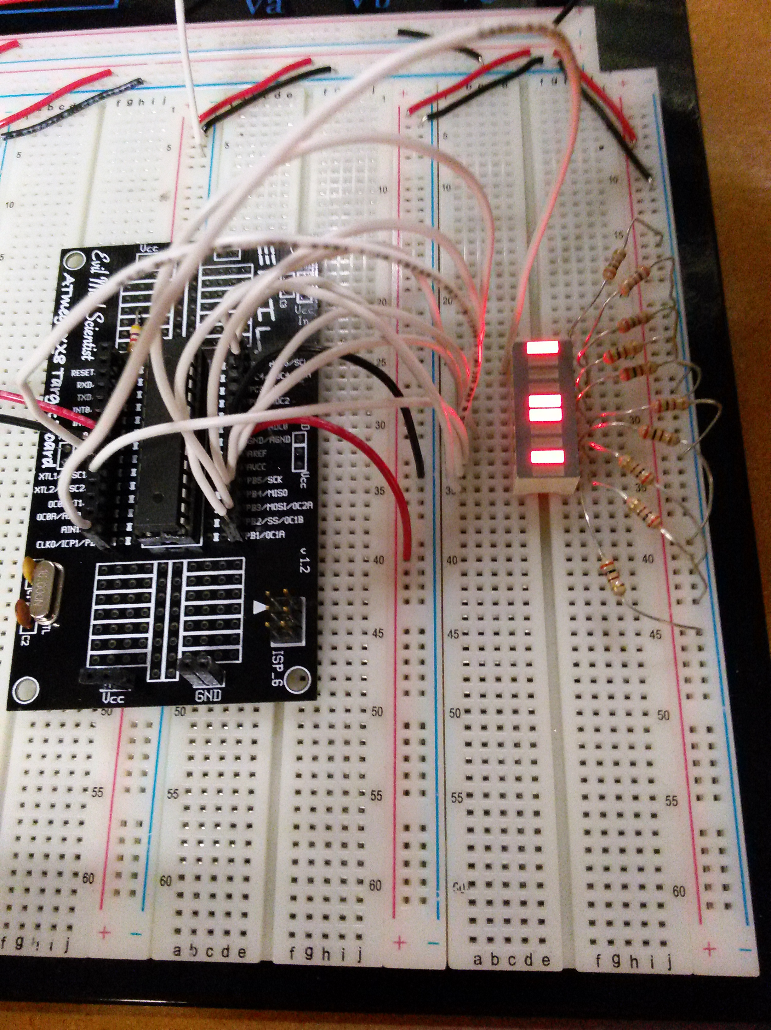

|  |  |  |  |
| --- | --- | --- | --- |
| 10. | VIDEO LINKS OF EACH DEMO |  |  |
| <https://www.youtube.com/watch?v=Hx-GPhyXN38>  The lab in 350 was very noisy while I was filming the video so I took out the sound. | | | |
| 11. | GITHUB LINK OF THE DA |  |  |
| https://github.com/michael-ghisilieri/CpE301_DAs.git | | | |

**Student Academic Misconduct Policy**

<http://studentconduct.unlv.edu/misconduct/policy.html>

“This assignment submission is my own, original work”.

Michael Ghisilieri